Testing document for MS Decom activities

Project: Z_2T65_CSL_SIR

System : xFE

CD: XXXXXXXX.

Transport request: XXXXXXXX

—---------------------------------------------------------------------------------------------------------------------------------

1. Open the application from the Fiori launchpad and click on **Go** button after entering selection criteria. It will give below results.
2. Procurement Operations A/C related Services.

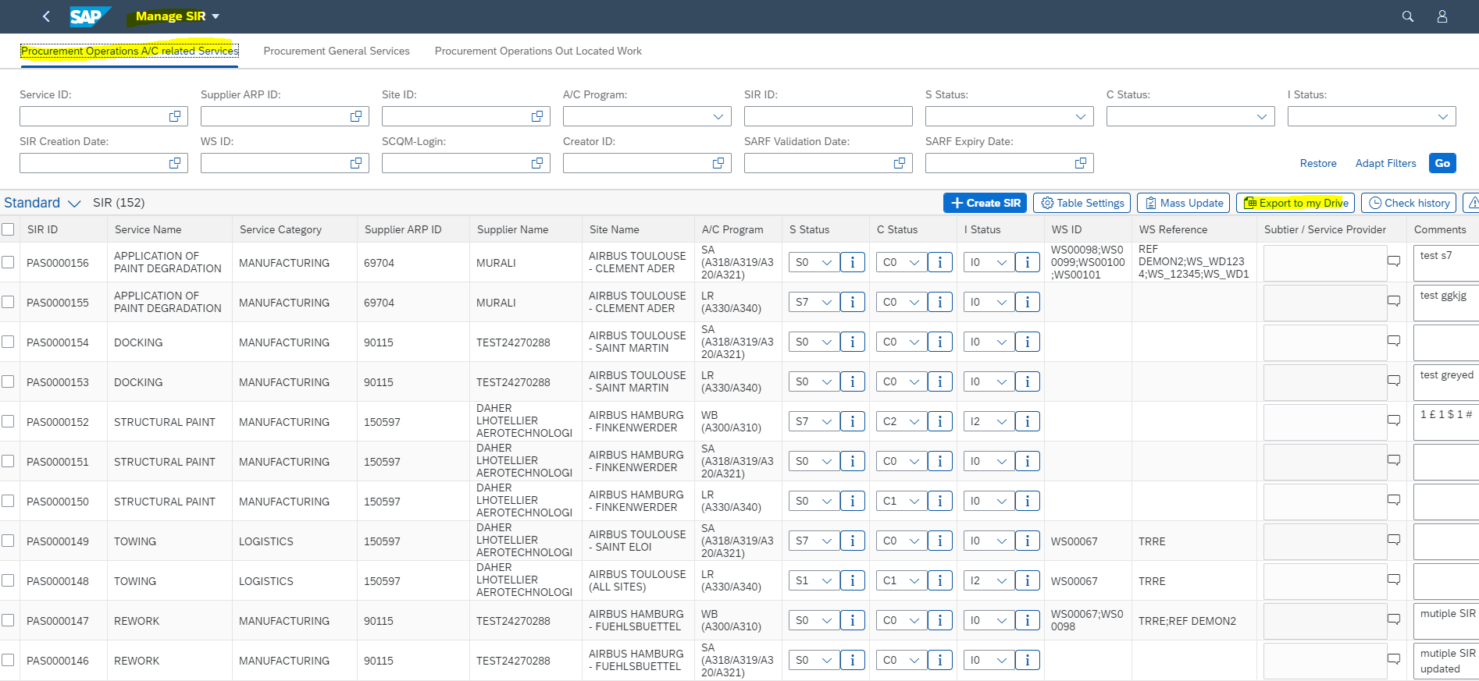

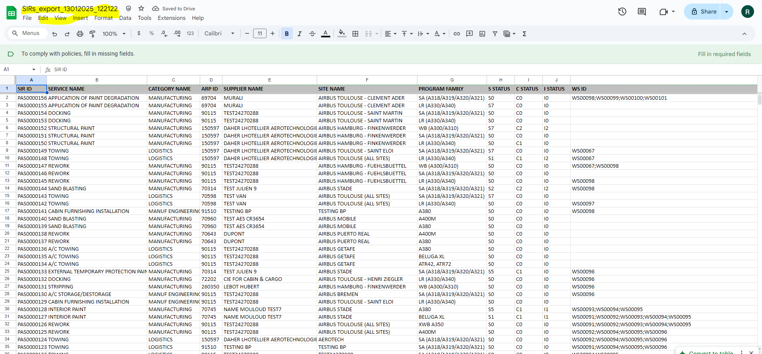

1. Procurement General Services

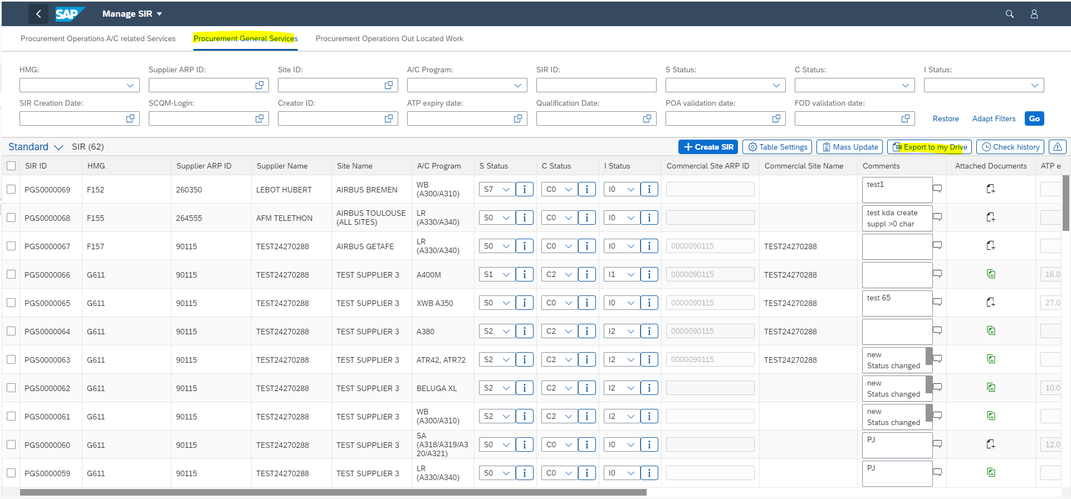

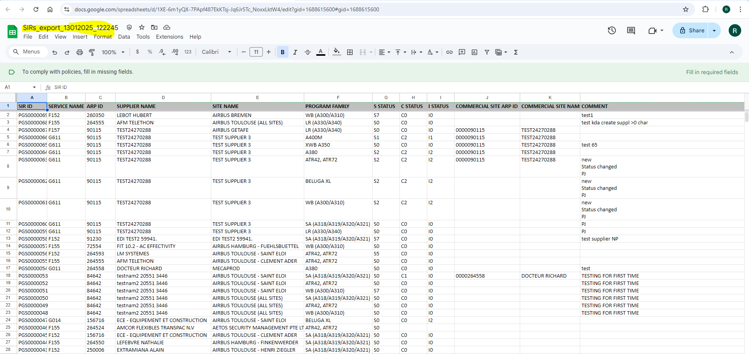

1. Procurement Operations Out Located Work

